**Experiment No - 05**

===============================================================================

**Author Name :** Vinni Fengade

**Roll No. :** 67

**Sem & Sec :** 7th Sem - CSE [B]

===============================================================================

**Aim :** Demonstrate the creation of storage services in public cloud based on the

given scenario.

**Problem Statements:**

You are tasked with demonstrating the usage of different AWS storage services to a group of colleagues who are new to cloud computing. Your goal is to provide hands-on experience with Amazon S3, Amazon EBS, and Amazon EFS. Create a step-by-step guide for this demonstration,covering the creation, configuration, and use of each storage service.

**Task 1:**

Demonstrate the process of creating a static website using Amazon S3 bucket storage to a group of beginners. The website should include multiple HTML files, CSS stylesheets, and images.

Describe the step-by-step process, including setting up the S3 bucket, configuring the necessary permissions, and ensuring the website is accessible via a web browser..

**===============================================================================**

**Task 1**

**===============================================================================**

**Create a AWS S3 bucket**

Step 1 -: Open Amazon S3 from Services -> Click Create bucket.

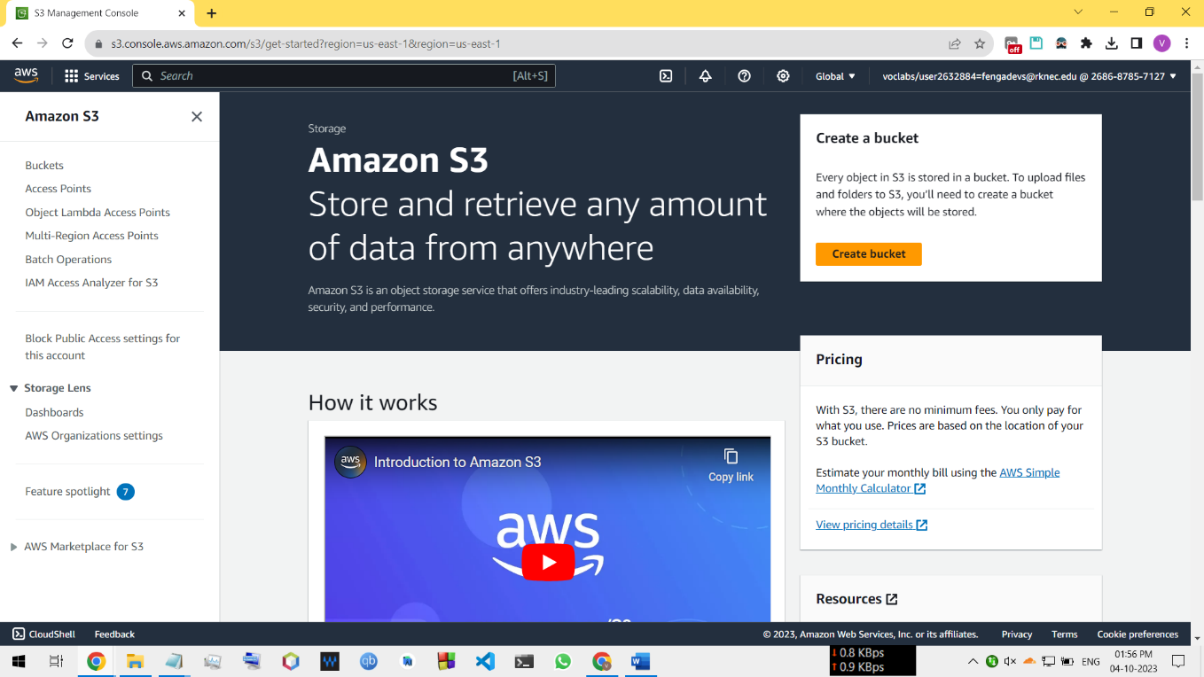

Step 2 -: Open Amazon S3 from Services -> Click Create bucket.

**===============================================================================**

**Task 2 (Accessible VM instance via SSH/PUTTY (Ubuntu))**

**===============================================================================**

**===============================================================================**

**Task 3 (Scalability and Flexibility of VM Resources)**

**===============================================================================**